­

**Predictive Modeling**

Jason Willis

College of Information Technology,

Western Governors University

Dr. Eric Straw

January 5th, 2021

Table of Contents for Each Rubric

Part I: Research Question

Describe Purpose, Summarize Research Question and Define Objectives: 3

***Part II: Method Justification***

Summarize Model Assumptions, Benefits of Python and Why Multiple Regression7

***Part III: Data Preparation***

Describe Data Preparation, Summary Statistics, Visualizations and Code 8

Part IV: Model Comparison and Analysis

Compare Initial and Reduced Models, Justify Variable Selection 15

Provide Reduced Multiple Regression Models15

Analyze Data Using Reduced Mode, Explain with Residual Error15

Part V: Data Summary and Implications

Summarize 16

Part VI: Demonstration

Video 17

Sources for Third-Party Code 17

Sources 18

# Hospital Readmission Problem

For our chain of hospitals to lower readmission concerns, we need to identify patients who have increased risk of rehospitalization within a month of their release. According to Schuller (2020), non-obese adults were 21% less likely to be readmitted than obese adults. A readmission study by Gert, et. al. (2002) showed a correlation between longer initial hospital stays and readmission. Within the provided dataset, I’m leveraging these studies to help create my hypothetical question and shape my approach in finding potential patient groups with a statistically significant chance for readmission outcomes.

After viewing the provided medical_clean.csv data set and accompanying data dictionary, there seems to be some patient groupings which are aligned with the research mentioned above. For instance, the following patient data fields: Diabetes, Readmissions, Total Charges, and Initial Says (inpatient) both caught my attention and were underscored by the research mentioned above. While my initial feelings towards these variables might make them feel related, are they?

## A1 - Research Question

Do the following three predictors: Initial Days, Readmissions, and Diabetes explain the variation in total charges?

**A2 - Objectives and Goals**

The goal of our analysis is to logically investigate the provided data to provide evidence to support or reject the hypothesis. Some data will need to be converted from categorical to numerical data types to process. Our objective is to see how, if at all, a patient’s initial inpatient days, readmissions and diabetes data correlate with the total charges incurred through patient care.

B1 – Summary of Assumptions

Applying multiple regression will help understand if Total Charges is dependent on the following independent predictor variables:

* Initial Days (inpatient)
* If the patient was readmitted
* If the patient has diabetes

We should be able to visualize a linear relationship between the dependent and independent variables.

## B2 – Tool Benefits

Python and the chosen libraries (pandas, numpy, seaborn, matplotlib, statsmodels, sklearn) were all chosen to help structure, clean, transform, manipulate, analyze and visualize the data set quickly, accurately and efficiently.

**B3** – **Appropriate Technique**

Multiple regression was chosen to analyze if there is a strong relationship between a dependent variable and more-than-one independent variable. As Larose (2019) stated: “Multiple regression modeling approximates the relationship between a set of *p > 1* predictors and a single continuous target, using a p-diminsional plane or hyperplane.” Multiple regression was chosen for this scenario since it has more than one independent variable. An equation of **Y’ = a + b1X1 + b2X2** will be utilized. Understanding chosen predictor variable relationships could help our hospital chain better predict potential patient care and readmissions by using the patient’s total charge value as a proxy.

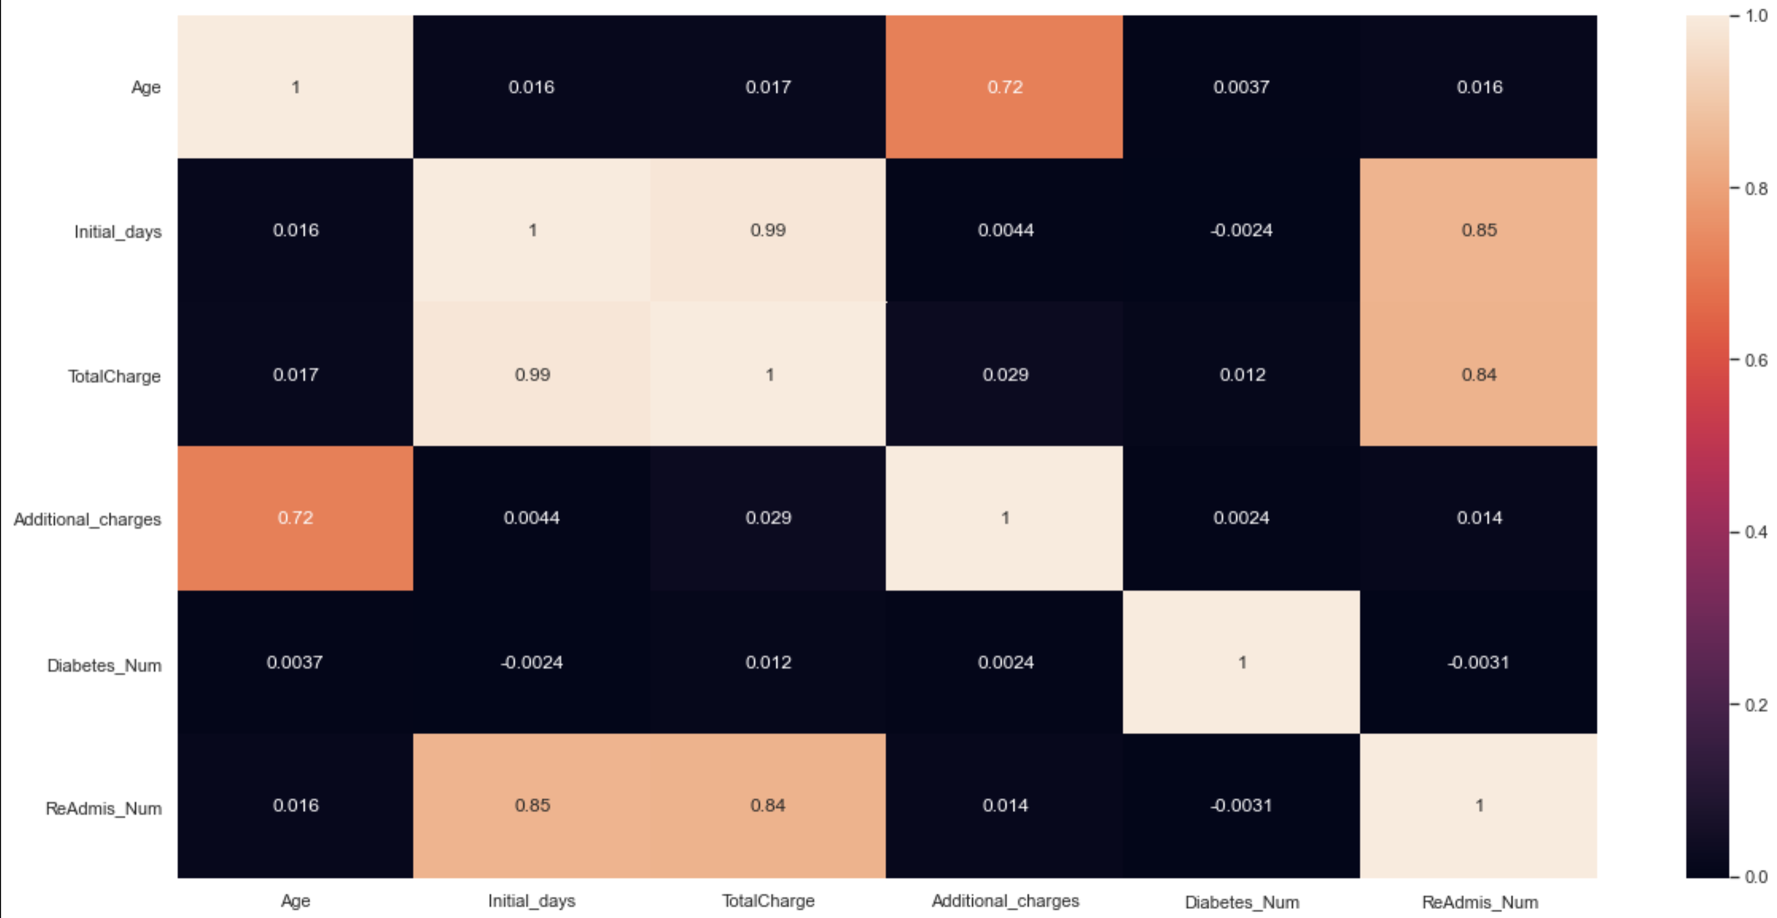

Figure 1 – Heat map of Data Field Correlation Tests (pruned_df_num)

As you can see above in the Figure 1 heatmap, a reduced set of data fields display significant correlation with other data fields, are part of the hypothesis, or both.

**C1** – **Data Goals**

From the original data set of 10,000 rows and 50 columns, attention was focused on discarding fields which did not address the hypothesis. To understand the data, df.info() was run which provided range, shape, completeness (all columns contained Non-Null data) and field data types. Next, df.describe() was used to provide a descriptive statistical summary of the field’s central tendency and dispersion. I split the data frame into numeric and categorical subsets (df_num and df_cat respectively), and used pandas describe() method to help me get a feel of the data.

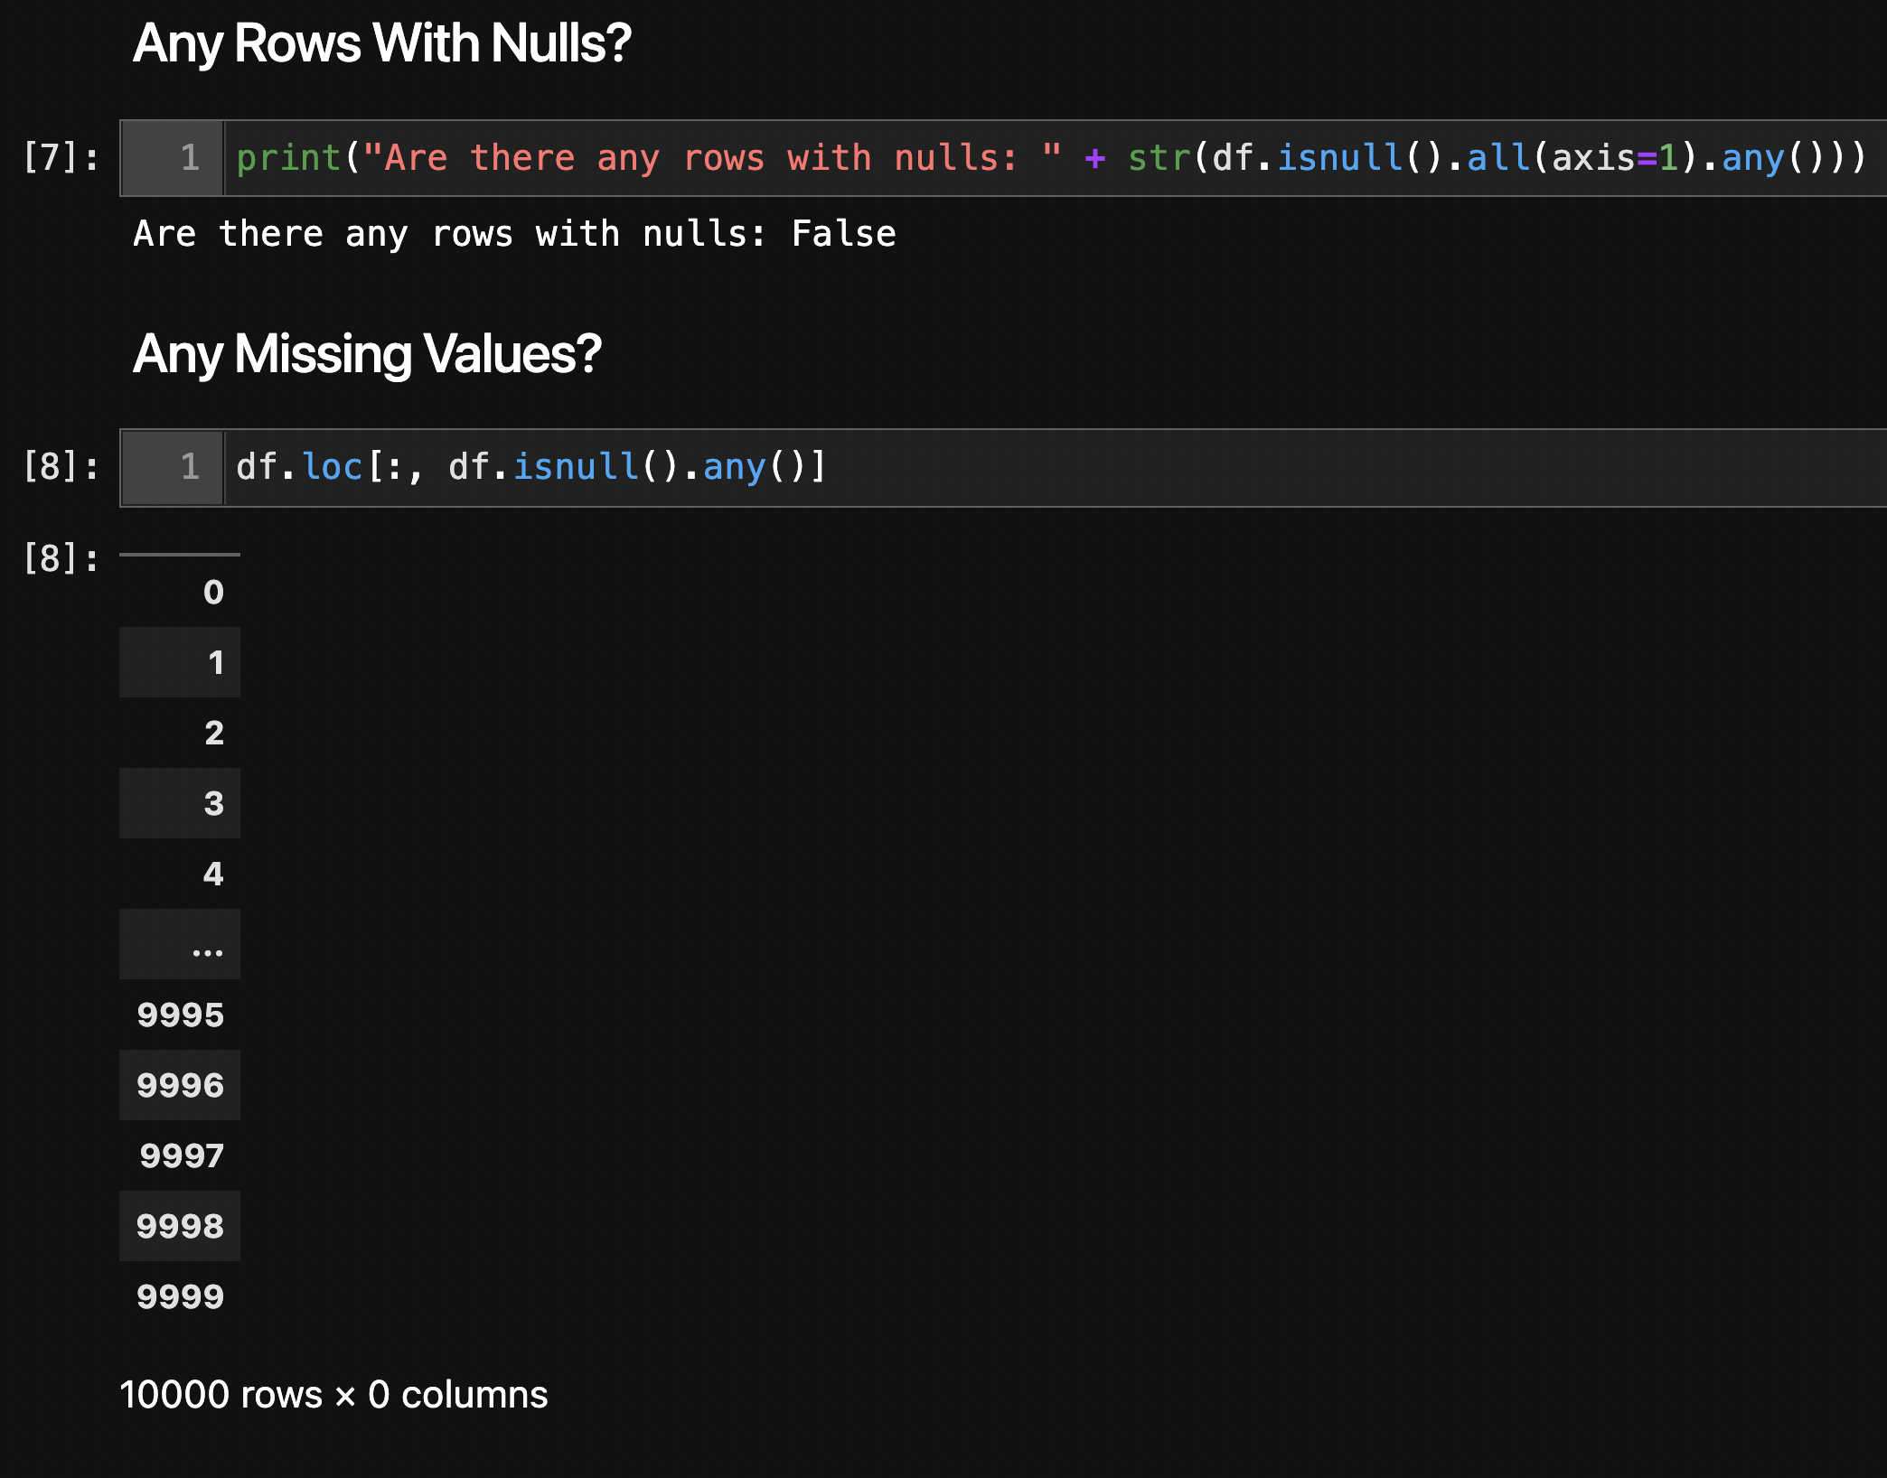

Figure 2 - Looking for Nulls

Next, dropped columns unrelated to the hypotheses and converted predictive categorical data to numbers in order to analyze.

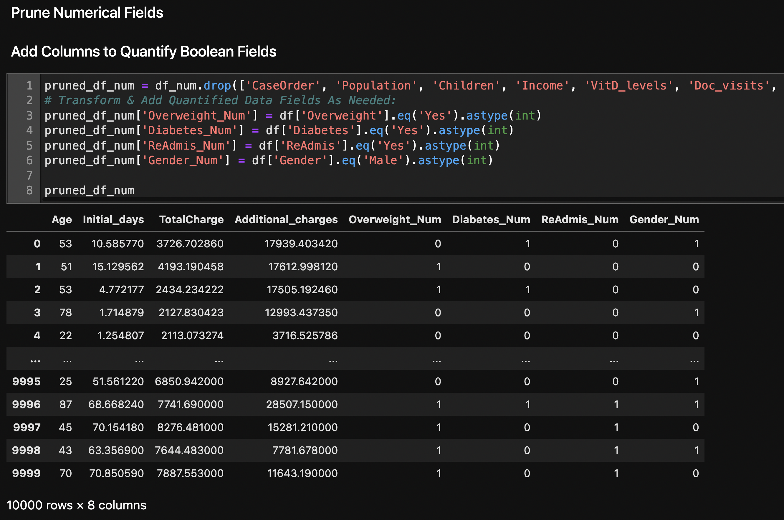

Figure 3 - Pruning Data And Converting Categorical Fields to Numerical

C2 – Summary Statistics

As stated in the Data Goals, to answer the selected research question, the target variable and all predictor variables remained in the data frame to analyze. The pandas describe() method was used to provide summary statistics.

C3 – Steps to Prepare Data

In addition to some cleaning, wrangling, removing and transformation of data (Figure 2 and 3), pairplot was used from the seaborn library. This method helps visualize relationships by pairing variables on an X and Y axis (Figure 4).

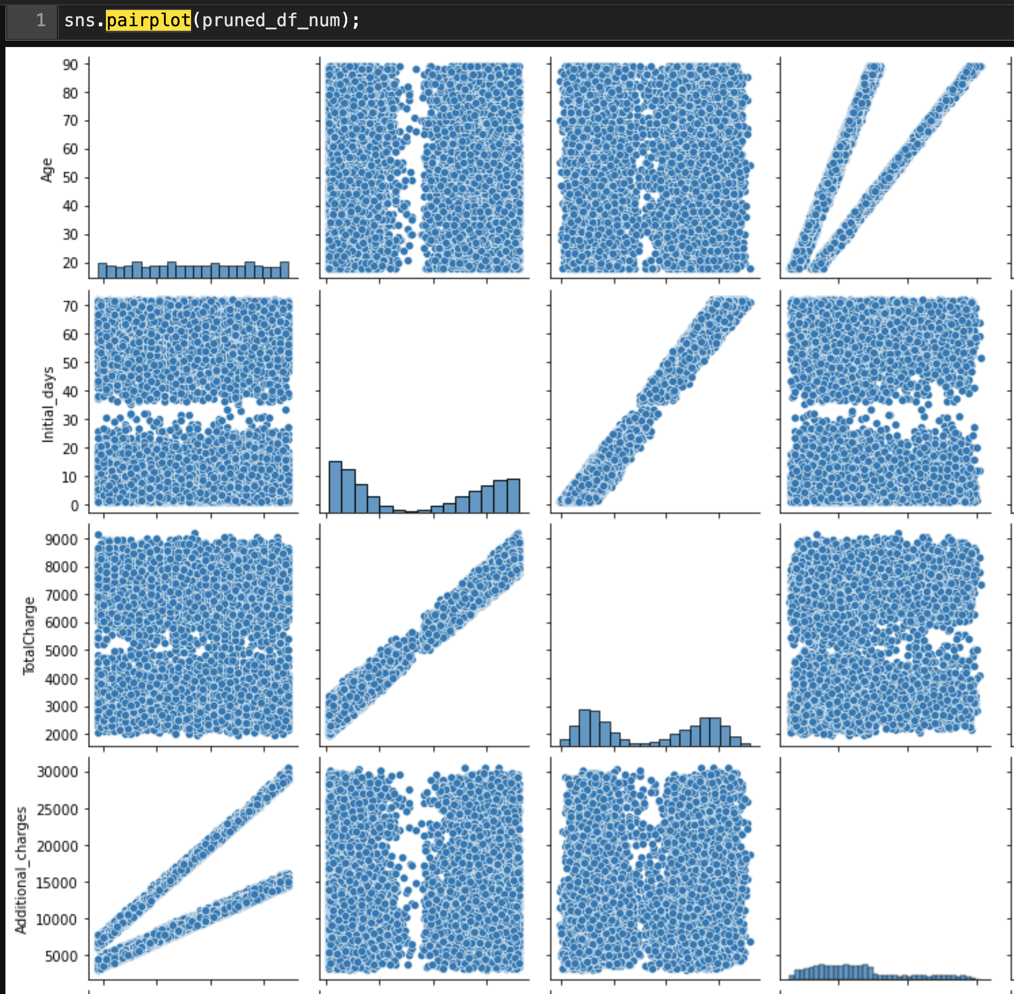

Figure 4 - Using Seaborn PairPlot to Visualize Relationships

Next, the pruned data set was ready to be set as training and testing data. A variable ‘X’ was set to the predictor variables and a variable ‘y’ was set to the target variable. A constant variable was added to the set of ‘X’ predictor variables, which creates a column with the value of 1.0. Then the multiple regression model was run (Figure 5).

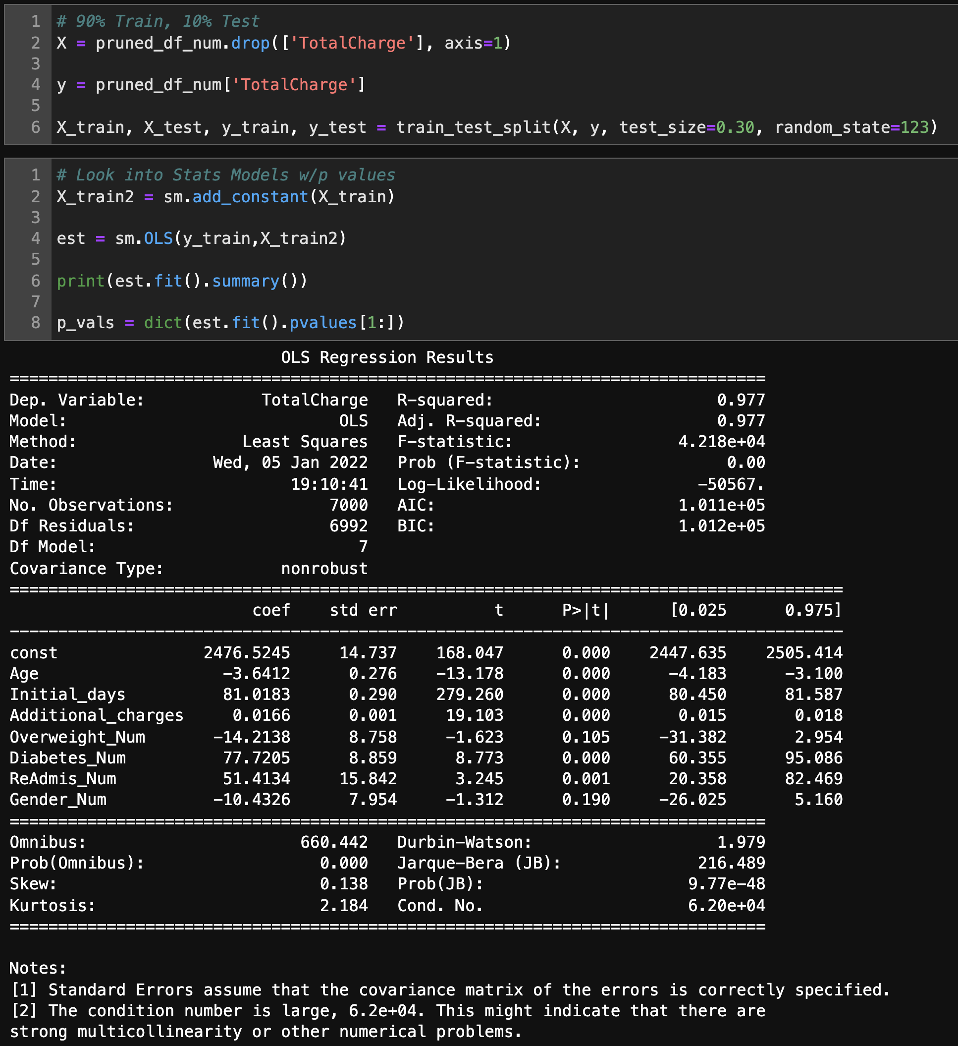

Figure 5 - Set up and Run the Multiple Regression Model

As you can see, there are two variables (Overweight_Num and Gender_Num) that were above a p-value threshold of 0.05. These were removed (Figure 6) and the model was run again (Figure 7).

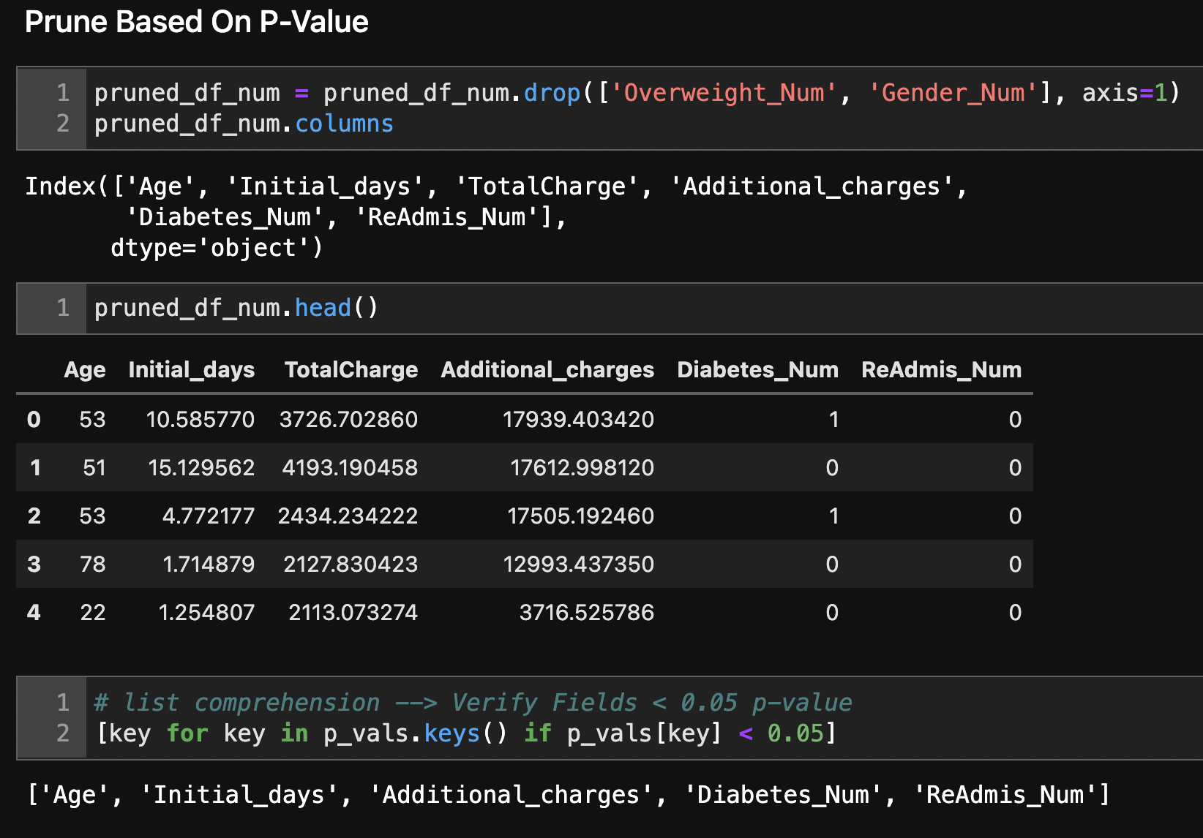

Figure 6 - Remove Variables Based On P-Value Threshold

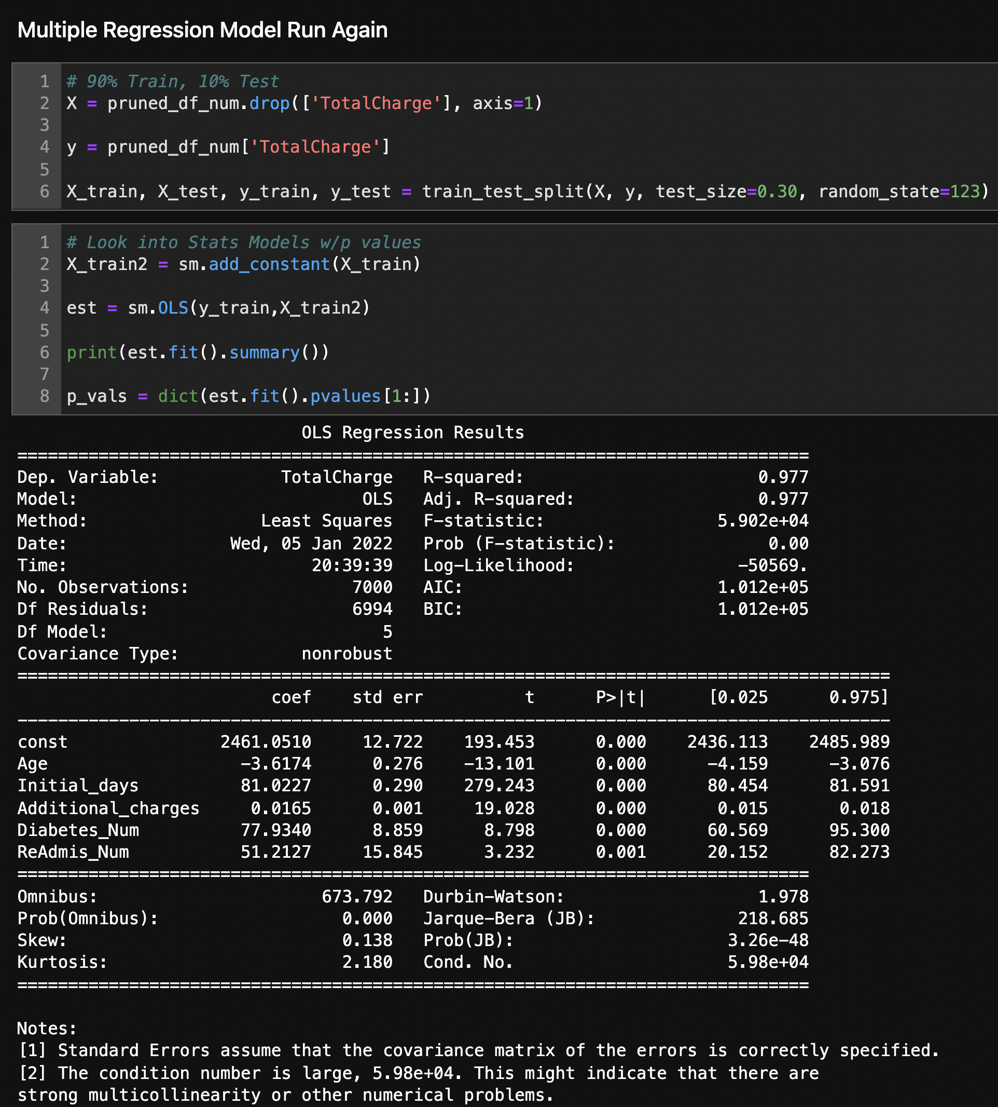

Figure 7 - Multiple Regression Model Run Again­­

C4 – Visualizations

The following univariate (Table 1) and bivariate (Figure 8) visualizations are from the cleaned and reduced data set. The bivariate visualization includes the target variable.

|  |  |  |
| --- | --- | --- |
|  |  |  |

Table 1 - Univariate Visualizations

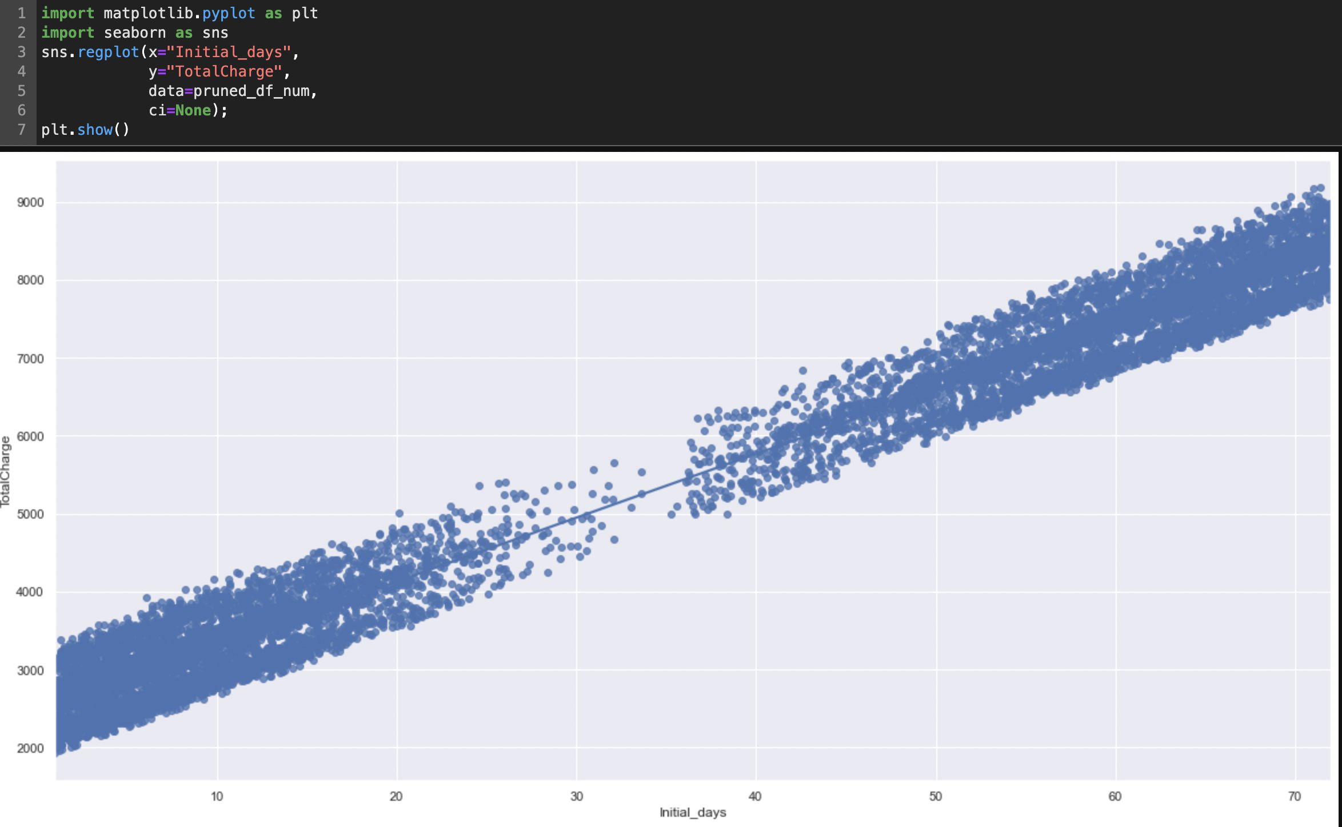

Figure 8 - Bivariate Visualization

**Model Comparison and Analysis**

Saved within the provided folder is the “JWillis_ D208_PA1 - Multiple Regression.ipynb” file, demonstrating the steps taken to explore and analyze the provided data set from the “medical_clean.csv” file. Once Jupyter Notebook or JupyterLab is running, navigate to the open the “JWillis_ D208_PA1 - Multiple Regression“ folder. From there, you will find the JWillis_ D208_PA1 - Multiple Regression.ipynb file and the “medical_clean.csv” file. Run all cells by navigating to Cells 🡪 ‘Run All’ in Jupyter Notebook or View 🡪 ‘Run All Cells’ from within JupyterLab. The first step is to import libraries and read the raw data from the CSV. Once the libraries are imported, the data is read into the notebook. Ensure the medical_raw_data.csv file is kept in the same folder or provide the correct path when reading in the data.

**D2** – **Justification of Model Reduction**

The model’s variables was further reduced (Figure 6) after initially running and comparing variable p-values to a threshold of 0.05.

**D3** –Reduced Multiple Regression Model

Submission provides a reduced multiple regression model, including categorical and continuous variables, aligned with the hypothesis.

**E1 – Model Comparison**

Using stepwise regression helped logically choose which variables to keep and which variables to remove. As seen in Figure 5 and 6, while looking at the “P > |t|” column and comparing coefficients against a p-value of 0.05, I kept significant variables that were less than this threshold. In Figure 9, model evaluation metrics and a residual plot are displayed. With a mean total charge is $5,312, the evaluation metrics state:

* Mean Absolute Error (MAE) states total charges will be +/- $279
* The Root Mean Squared Error (RMSE) states total charges will be +/- $339

With an R2 or measure of fit value of 0.976, confidence in this model should be high.

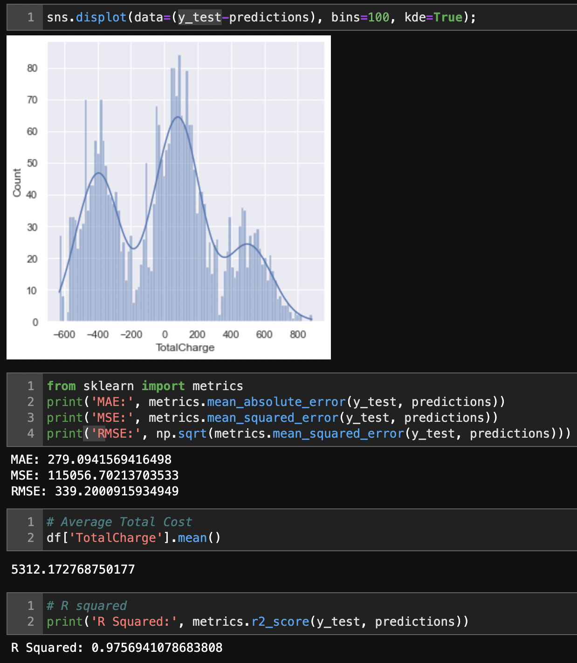

Figure 9 - Model Comparisons

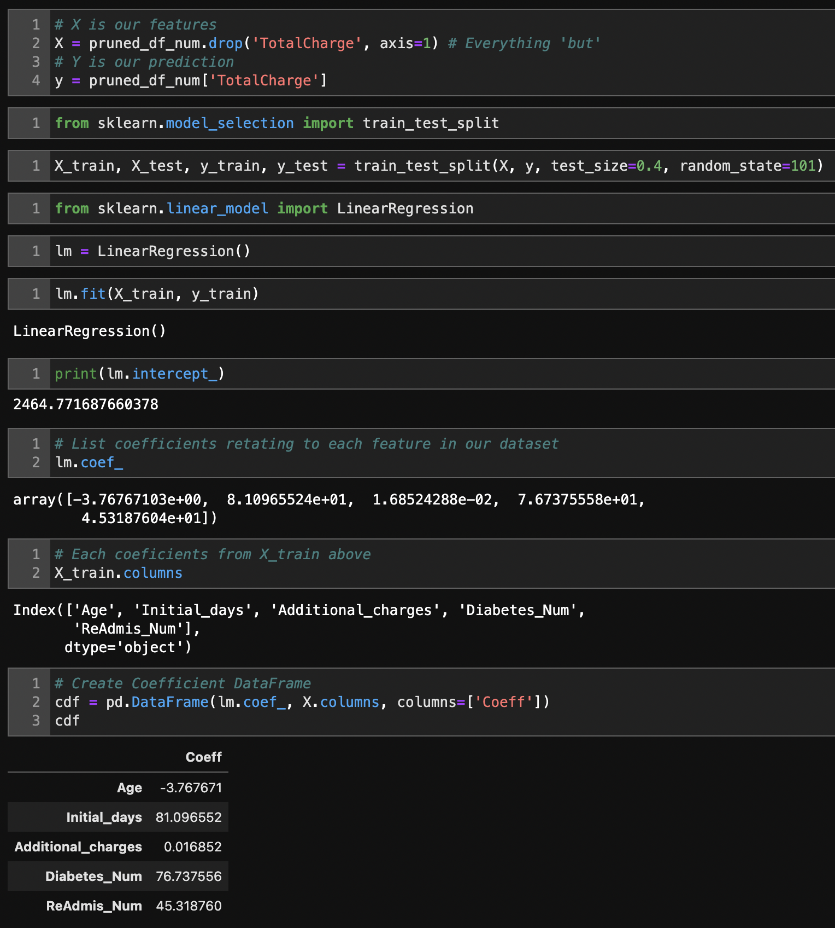

Figure 10 - Model Coefficients

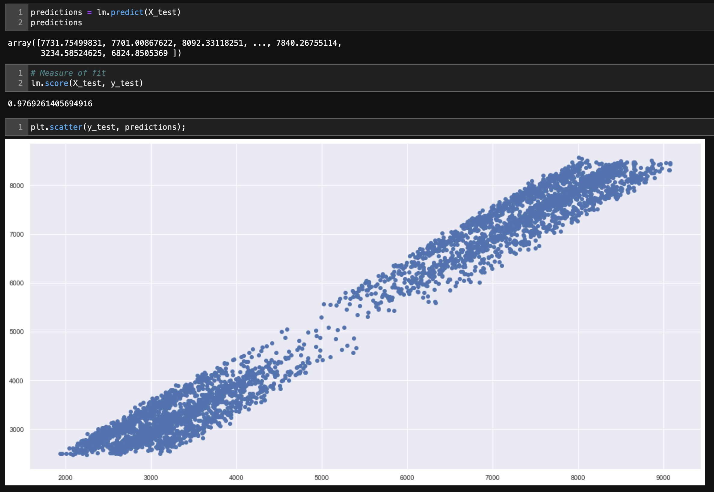

Figure 11 - Model Predictions

**Data Summary and Implications**

In the previous section, the source files were provided and either Jupyter Notebook or JupyterLab should be open. By running the cells, you should see output from all calculations performed, i.e. Regression, Univariate and Bivariate analysis.

**E3 – Code**

Code is provided in the JWillis_ D208_PA1 - Multiple Regression.ipynb file.

**F2 – Recommendations**

Looking at the Regression model, based on the coefficients, the three predictor variables (Initial_days, ReAdmis_Num, and Diabetes_Num) are all positively and significantly (due to p-values) correlated with the response variable of Total_charges. Therefore, there is evidence where longer hospital stays, previous readmissions, and diabetes are all predictors of a more expensive hospital stay of a patient. We should seek to focus this subset of patients in order to reduce the length of hospital stays, overall costs while freeing up beds.

**G – Panopto Demonstration**

Panopto video Will be uploaded once report is finalized.

**H – Sources for Third-Party Code**

* Help using Markdown: <https://www.markdownguide.org/basic-syntax/>
* Help to see ALL columns: <https://stackoverflow.com/questions/24524104/pandas-describe-is-not-returning-summary-of-all-columns>
* Help to create a better histogram design: <https://mode.com/example-gallery/python_histogram/>
* Matplotlib Help: <https://matplotlib.org/2.1.2/api/_as_gen/matplotlib.pyplot.plot.html>
* Multiple ways to conduct ANOVA: <https://www.marsja.se/four-ways-to-conduct-one-way-anovas-using-python/>
* Numpy Help: <https://numpy.org/doc/stable/>
* Pandas Help: <https://pandas.pydata.org/docs/user_guide/index.html#user-guide>
* Python Help: <https://docs.python.org/3.9/library/index.html>
* Scipy.stats Help: <https://docs.scipy.org/doc/scipy/reference/tutorial/stats.html>

## References

Bruce, P., C., & Bruce, A (2020). Practical Statistics for Data Scientists: 50+ Essential Concepts Using R and Python. O’Reilly Media. <https://learning.oreilly.com/library/view/practical-statistics-for/9781492072935/titlepage01.html>

Larose, D., C., & Larose, D., T. (2019). Data Science Using Python and R. Wiley. <https://www.wiley.com/en-us/Data+Science+Using+Python+and+R-p-9781119526810>

Creating Histograms Using Pandas (2021, October 20) Retrieved from: <https://mode.com/example-gallery/python_histogram/>

Gert P Westert, Ronald J Lagoe, Ilmo Keskimäki, Alastair Leyland, Mark Murphy,

An international study of hospital readmissions and related utilization in Europe and the USA,

Health Policy, Volume 61, Issue 3, 2002, Pages 269-278, ISSN 0168-8510, <https://doi.org/10.1016/S0168-8510(01)00236-6>. (<https://www.sciencedirect.com/science/article/pii/S0168851001002366>)

Hunter, J., Dale, D., et al. — Matplotlib 2.1.2 documentation for Styling Output. (2012). Matplotlib.org. <https://matplotlib.org/2.1.2/api/_as_gen/matplotlib.pyplot.plot.html>

Schuller K. A. (2020). Is obesity a risk factor for readmission after acute myocardial infarction?  *Journal of healthcare quality research*, *35*(1), 4–11. <https://doi.org/10.1016/j.jhqr.2019.09.002>